**Project Design Phase-II - Data Flow Diagram & User Stories**

|  |  |
| --- | --- |
| Date | June 2025 |
| Team ID | LTVIP2025TMID57241 |
| Project Name | Service Desk for Customer Complaint Resolution |
| Maximum Marks | 4 Marks |

**Data Flow Diagrams:**

A Data Flow Diagram (DFD) is a traditional visual representation of the information flows within a system. A neat and clear DFD can depict the right amount of the system requirement graphically. It shows how data enters and leaves the system, what changes the information, and where data is stored.

Example: DFD Level 0 (Industry Standard)

Example: (Simplified)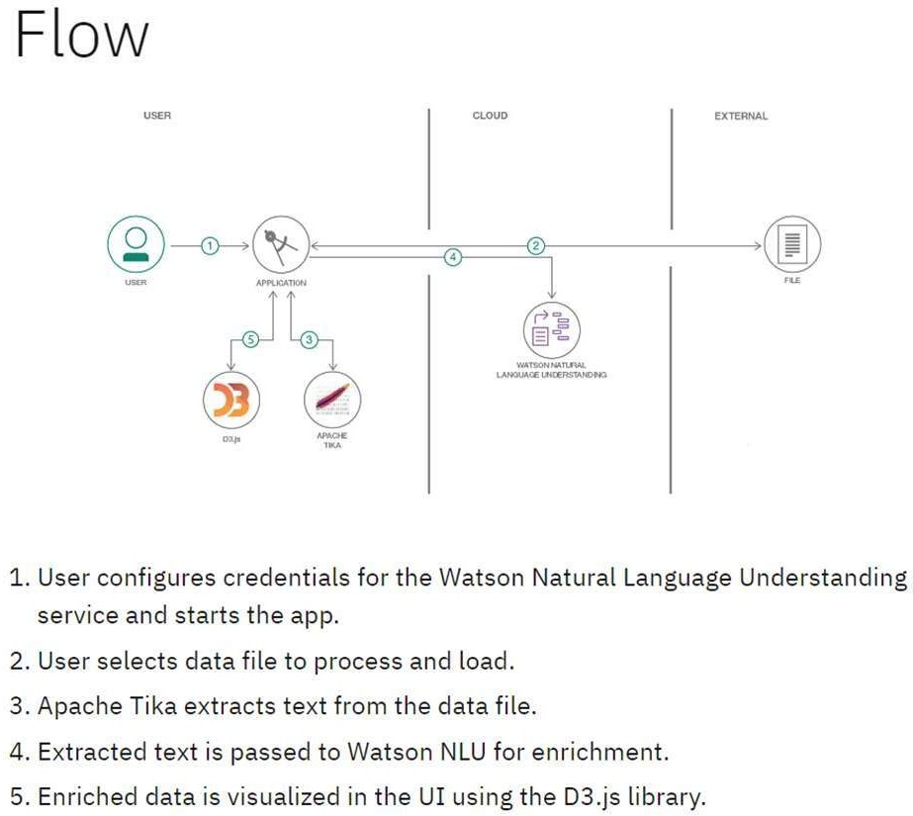

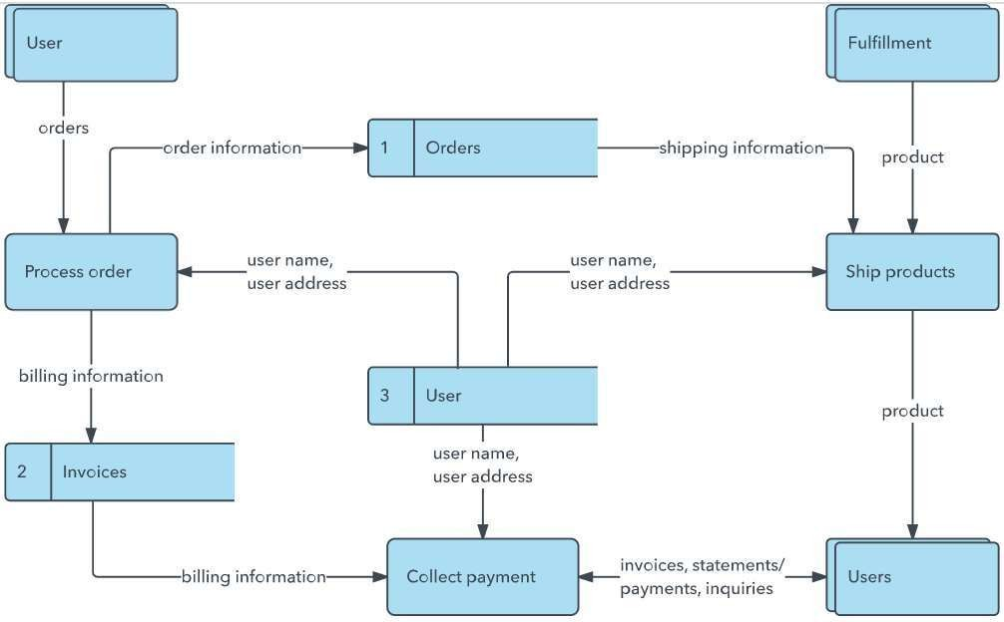

**User Stories**

|  |  |  |  |  |  |  |
| --- | --- | --- | --- | --- | --- | --- |
| **User Type** | **Functional**  **Requirement (Epic)** | **User Story Number** | **User Story / Task** | **Acceptance Criteria** | **Priority** | **Release** |
| Customer (Mobile user) | Registration | USN-1 | As a user, I can register for the application by entering my email, password, and  confirming my password. | I can access my account / dashboard | High | Sprint-1 |
|  |  | USN-2 | As a user, I will receive confirmation email  once I have registered for the application | I can receive confirmation  email & click confirm | High | Sprint-1 |
|  |  | USN-3 | As a user, I can register for the application through Facebook | I can register & access the dashboard with Facebook  Login | Low | Sprint-2 |
|  |  | USN-4 | As a user, I can register for the application  through Gmail | I can register & access the  dashboard using Gmail login | Medium | Sprint-1 |
|  | Login | USN-5 | As a user, I can log into the application by  entering email & password | I can successfully login and  reach the dashboard | High | Sprint-1 |
|  | Dashboard | USN-6 | As a user, I can view my submitted  complaints and their status | I can view the complaint list  and their current status | High | Sprint-2 |
|  | Complaint Submission | USN-7 | As a user, I can submit a complaint by filling form and attaching files | I receive confirmation after submission and it appears in  list | High | Sprint-2 |
|  | Chat | USN-8 | As a user, I can chat with the assigned  agent | I can view responses and  reply in real time | Medium | Sprint-3 |
| Customer (Web  user) | Responsive Web | USN-9 | As a user, I can use the app smoothly from  desktop or mobile browser | All functionalities work  correctly across devices | Medium | Sprint-3 |
| Customer Care  Executive | Complaint Handling | USN-10 | As an agent, I can view assigned  complaints | Assigned complaints are  visible on agent dashboard | High | Sprint-3 |
|  |  | USN-11 | As an agent, I can chat with users to solve  the issue | Messages are exchanged  correctly and stored | High | Sprint-3 |
| Administrator | User Management | USN-12 | As an admin, I can view/manage all users and agents | User and agent list loads  properly with edit/delete options | Medium | Sprint-4 |

|  |  |  |  |  |  |  |
| --- | --- | --- | --- | --- | --- | --- |
| **User Type** | **Functional**  **Requirement (Epic)** | **User Story Number** | **User Story / Task** | **Acceptance Criteria** | **Priority** | **Release** |
|  | Complaint Routing | USN-13 | As an admin, I can assign complaints to  agents | Assigned agent receives the  complaint in their dashboard | High | Sprint-4 |
|  | Dashboard  Analytics | USN-14 | As an admin, I can view analytics such as  total complaints, resolved, pending etc. | Analytics dashboard loads  with charts and counts | Medium | Sprint-4 |